alpha = 2

1 run......

training 1 epoch...

68.80108213424683 seconds used......

1 training finished! average train loss: 1.5133293997018764

total clf loss: 145.74694755673409 total adv loss: 104.18606630712748

evaluating...

Confusion matrix, without normalization

[[ 33 47 16]

[ 12 265 78]

[ 19 62 638]]

Normalized confusion matrix

[[0.34375 0.48958333 0.16666667]

[0.03380282 0.74647887 0.21971831]

[0.02642559 0.08623088 0.88734353]]

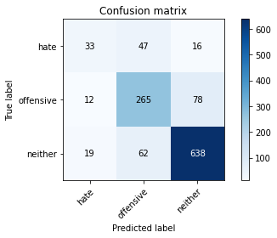

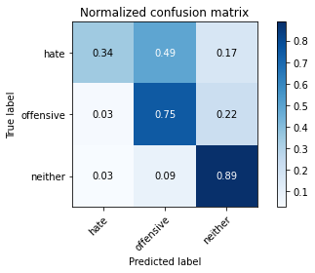

precision recall f1-score support

hate 0.52 0.34 0.41 96

offensive 0.71 0.75 0.73 355

neither 0.87 0.89 0.88 719

accuracy 0.80 1170

macro avg 0.70 0.66 0.67 1170

weighted avg 0.79 0.80 0.79 1170

average eval_loss: 0.49008490776611585, accuracy: 0.8

training 2 epoch...

68.70441436767578 seconds used......

2 training finished! average train loss: 0.9247192988793055

total clf loss: 86.86592013388872 total adv loss: 64.75919795967638

evaluating...

Confusion matrix, without normalization

[[ 35 36 25]

[ 7 243 105]

[ 2 26 691]]

Normalized confusion matrix

[[0.36458333 0.375 0.26041667]

[0.01971831 0.68450704 0.29577465]

[0.00278164 0.03616134 0.96105702]]

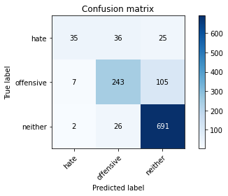

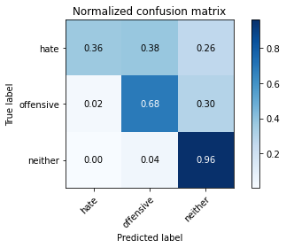

precision recall f1-score support

hate 0.80 0.36 0.50 96

offensive 0.80 0.68 0.74 355

neither 0.84 0.96 0.90 719

accuracy 0.83 1170

macro avg 0.81 0.67 0.71 1170

weighted avg 0.82 0.83 0.82 1170

average eval_loss: 0.4409622726804119, accuracy: 0.8282051282051283

training 3 epoch...

68.71869015693665 seconds used......

3 training finished! average train loss: 0.4844267095447096

total clf loss: 47.818153236061335 total adv loss: 32.76884852256626

evaluating...

Confusion matrix, without normalization

[[ 46 37 13]

[ 18 282 55]

[ 23 91 605]]

Normalized confusion matrix

[[0.47916667 0.38541667 0.13541667]

[0.05070423 0.7943662 0.15492958]

[0.03198887 0.12656467 0.84144645]]

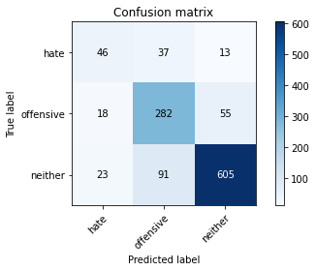

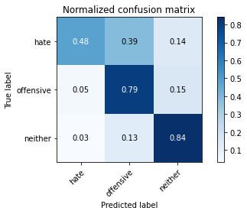

precision recall f1-score support

hate 0.53 0.48 0.50 96

offensive 0.69 0.79 0.74 355

neither 0.90 0.84 0.87 719

accuracy 0.80 1170

macro avg 0.71 0.70 0.70 1170

weighted avg 0.80 0.80 0.80 1170

average eval_loss: 0.5615051915332422, accuracy: 0.7974358974358975

training 4 epoch...

68.6285171508789 seconds used......

4 training finished! average train loss: 0.2774312180749531

total clf loss: 28.416335723828524 total adv loss: 18.251284723519348

evaluating...

Confusion matrix, without normalization

[[ 38 37 21]

[ 12 267 76]

[ 15 51 653]]

Normalized confusion matrix

[[0.39583333 0.38541667 0.21875 ]

[0.03380282 0.75211268 0.21408451]

[0.02086231 0.07093185 0.90820584]]

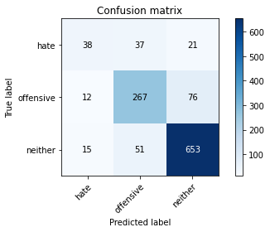

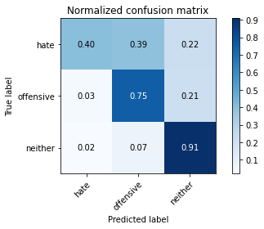

precision recall f1-score support

hate 0.58 0.40 0.47 96

offensive 0.75 0.75 0.75 355

neither 0.87 0.91 0.89 719

accuracy 0.82 1170

macro avg 0.74 0.69 0.70 1170

weighted avg 0.81 0.82 0.81 1170

average eval_loss: 0.6210354192150851, accuracy: 0.8188034188034188

training 5 epoch...

68.65547347068787 seconds used......

5 training finished! average train loss: 0.154063665933915

total clf loss: 16.169802736258134 total adv loss: 9.94054746555048

evaluating...

Confusion matrix, without normalization

[[ 61 18 17]

[ 51 239 65]

[ 23 51 645]]

Normalized confusion matrix

[[0.63541667 0.1875 0.17708333]

[0.14366197 0.67323944 0.18309859]

[0.03198887 0.07093185 0.89707928]]

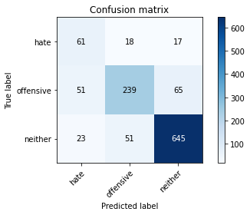

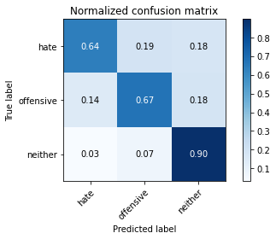

precision recall f1-score support

hate 0.45 0.64 0.53 96

offensive 0.78 0.67 0.72 355

neither 0.89 0.90 0.89 719

accuracy 0.81 1170

macro avg 0.71 0.74 0.71 1170

weighted avg 0.82 0.81 0.81 1170

average eval_loss: 0.7645046098820739, accuracy: 0.8076923076923077

training 6 epoch...

68.7237901687622 seconds used......

6 training finished! average train loss: 0.11044870199173944

total clf loss: 10.70451018481981 total adv loss: 7.570243102105451

evaluating...

Confusion matrix, without normalization

[[ 35 35 26]

[ 19 256 80]

[ 17 42 660]]

Normalized confusion matrix

[[0.36458333 0.36458333 0.27083333]

[0.05352113 0.72112676 0.22535211]

[0.02364395 0.05841446 0.91794159]]

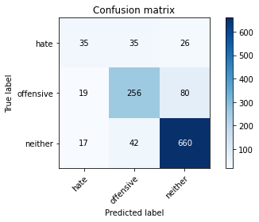

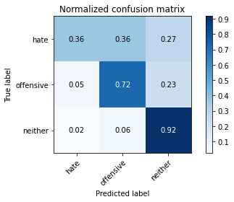

precision recall f1-score support

hate 0.49 0.36 0.42 96

offensive 0.77 0.72 0.74 355

neither 0.86 0.92 0.89 719

accuracy 0.81 1170

macro avg 0.71 0.67 0.68 1170

weighted avg 0.80 0.81 0.81 1170

average eval_loss: 0.8082702436752743, accuracy: 0.8128205128205128

training 7 epoch...

68.88630223274231 seconds used......

7 training finished! average train loss: 0.08204856280707078

total clf loss: 7.758074102399405 total adv loss: 5.720644836255815

evaluating...

Confusion matrix, without normalization

[[ 61 13 22]

[ 36 240 79]

[ 17 40 662]]

Normalized confusion matrix

[[0.63541667 0.13541667 0.22916667]

[0.10140845 0.67605634 0.22253521]

[0.02364395 0.05563282 0.92072323]]

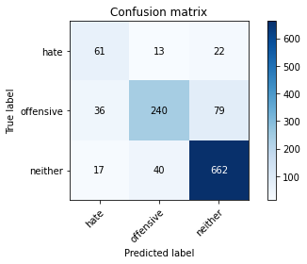

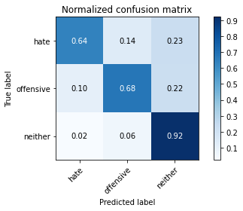

precision recall f1-score support

hate 0.54 0.64 0.58 96

offensive 0.82 0.68 0.74 355

neither 0.87 0.92 0.89 719

accuracy 0.82 1170

macro avg 0.74 0.74 0.74 1170

weighted avg 0.83 0.82 0.82 1170

average eval_loss: 0.8142620224379382, accuracy: 0.823076923076923

training 8 epoch...

68.72779059410095 seconds used......

8 training finished! average train loss: 0.07872875388681841

total clf loss: 7.522836848569568 total adv loss: 5.449845728395303

evaluating...

Confusion matrix, without normalization

[[ 57 12 27]

[ 26 240 89]

[ 10 42 667]]

Normalized confusion matrix

[[0.59375 0.125 0.28125 ]

[0.07323944 0.67605634 0.25070423]

[0.01390821 0.05841446 0.92767733]]

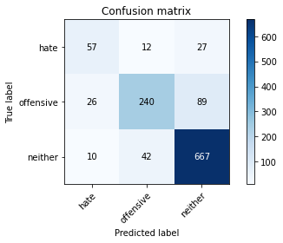

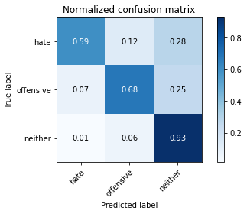

precision recall f1-score support

hate 0.61 0.59 0.60 96

offensive 0.82 0.68 0.74 355

neither 0.85 0.93 0.89 719

accuracy 0.82 1170

macro avg 0.76 0.73 0.74 1170

weighted avg 0.82 0.82 0.82 1170

average eval_loss: 0.8662646748283405, accuracy: 0.8239316239316239

training 9 epoch...

68.60237336158752 seconds used......

9 training finished! average train loss: 0.07795938117127134

total clf loss: 7.091562684072414 total adv loss: 5.575466243844858

evaluating...

Confusion matrix, without normalization

[[ 32 50 14]

[ 8 305 42]

[ 10 114 595]]

Normalized confusion matrix

[[0.33333333 0.52083333 0.14583333]

[0.02253521 0.85915493 0.11830986]

[0.01390821 0.15855355 0.82753825]]

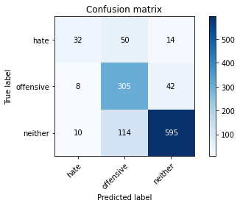

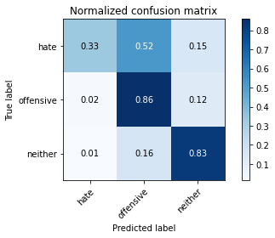

precision recall f1-score support

hate 0.64 0.33 0.44 96

offensive 0.65 0.86 0.74 355

neither 0.91 0.83 0.87 719

accuracy 0.80 1170

macro avg 0.73 0.67 0.68 1170

weighted avg 0.81 0.80 0.79 1170

average eval_loss: 1.0018912334373946, accuracy: 0.7965811965811965

training 10 epoch...

68.58783388137817 seconds used......

10 training finished! average train loss: 0.07621558532407348

total clf loss: 7.069536321389023 total adv loss: 5.382455310078512

evaluating...

Confusion matrix, without normalization

[[ 65 13 18]

[ 43 236 76]

[ 23 44 652]]

Normalized confusion matrix

[[0.67708333 0.13541667 0.1875 ]

[0.12112676 0.66478873 0.21408451]

[0.03198887 0.06119611 0.90681502]]

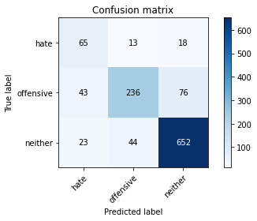

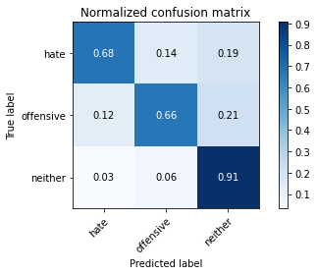

precision recall f1-score support

hate 0.50 0.68 0.57 96

offensive 0.81 0.66 0.73 355

neither 0.87 0.91 0.89 719

accuracy 0.81 1170

macro avg 0.73 0.75 0.73 1170

weighted avg 0.82 0.81 0.81 1170

average eval_loss: 0.8456245307668538, accuracy: 0.8145299145299145

2 run......

training 1 epoch...

68.66388154029846 seconds used......

1 training finished! average train loss: 1.4945644061280112

total clf loss: 142.99098533391953 total adv loss: 103.36854272335768

evaluating...

Confusion matrix, without normalization

[[ 43 30 23]

[ 25 250 80]

[ 13 61 645]]

Normalized confusion matrix

[[0.44791667 0.3125 0.23958333]

[0.07042254 0.70422535 0.22535211]

[0.01808067 0.08484006 0.89707928]]

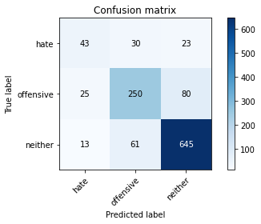

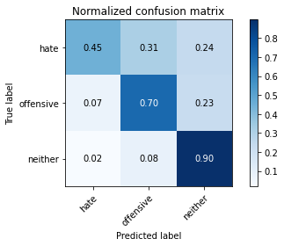

precision recall f1-score support

hate 0.53 0.45 0.49 96

offensive 0.73 0.70 0.72 355

neither 0.86 0.90 0.88 719

accuracy 0.80 1170

macro avg 0.71 0.68 0.69 1170

weighted avg 0.80 0.80 0.80 1170

average eval_loss: 0.48404743711827164, accuracy: 0.8017094017094017

training 2 epoch...

68.77440071105957 seconds used......

2 training finished! average train loss: 0.9005103897717264

total clf loss: 84.840118534863 total adv loss: 62.93965629860759

evaluating...

Confusion matrix, without normalization

[[ 25 35 36]

[ 6 229 120]

[ 1 18 700]]

Normalized confusion matrix

[[0.26041667 0.36458333 0.375 ]

[0.01690141 0.64507042 0.33802817]

[0.00139082 0.02503477 0.97357441]]

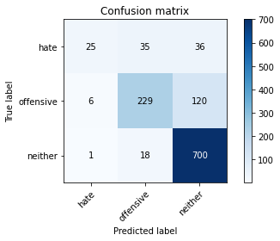

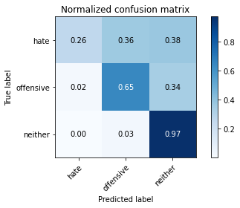

precision recall f1-score support

hate 0.78 0.26 0.39 96

offensive 0.81 0.65 0.72 355

neither 0.82 0.97 0.89 719

accuracy 0.82 1170

macro avg 0.80 0.63 0.67 1170

weighted avg 0.81 0.82 0.80 1170

average eval_loss: 0.5024952916902, accuracy: 0.8153846153846154

training 3 epoch...

68.74702310562134 seconds used......

3 training finished! average train loss: 0.4227140729243939

total clf loss: 42.865232065320015 total adv loss: 28.024930528597906

evaluating...

Confusion matrix, without normalization

[[ 52 32 12]

[ 23 273 59]

[ 30 59 630]]

Normalized confusion matrix

[[0.54166667 0.33333333 0.125 ]

[0.06478873 0.76901408 0.16619718]

[0.04172462 0.08205841 0.87621697]]

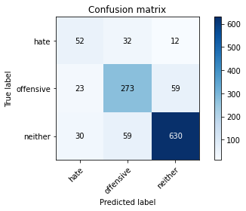

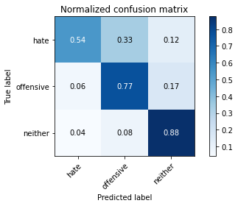

precision recall f1-score support

hate 0.50 0.54 0.52 96

offensive 0.75 0.77 0.76 355

neither 0.90 0.88 0.89 719

accuracy 0.82 1170

macro avg 0.71 0.73 0.72 1170

weighted avg 0.82 0.82 0.82 1170

average eval_loss: 0.5420997496378623, accuracy: 0.8162393162393162

training 4 epoch...

68.76862859725952 seconds used......

4 training finished! average train loss: 0.2522926916185225

total clf loss: 25.64368043001741 total adv loss: 16.69640475336928

evaluating...

Confusion matrix, without normalization

[[ 48 35 13]

[ 16 286 53]

[ 10 83 626]]

Normalized confusion matrix

[[0.5 0.36458333 0.13541667]

[0.04507042 0.8056338 0.14929577]

[0.01390821 0.11543811 0.87065369]]

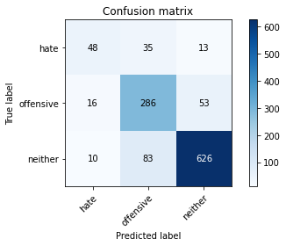

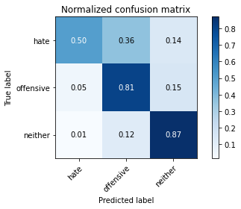

precision recall f1-score support

hate 0.65 0.50 0.56 96

offensive 0.71 0.81 0.75 355

neither 0.90 0.87 0.89 719

accuracy 0.82 1170

macro avg 0.75 0.73 0.74 1170

weighted avg 0.82 0.82 0.82 1170

average eval_loss: 0.5997124555504928, accuracy: 0.8205128205128205

training 5 epoch...

68.54135918617249 seconds used......

5 training finished! average train loss: 0.15254896570347312

total clf loss: 15.627150300657377 total adv loss: 10.034653806418646

evaluating...

Confusion matrix, without normalization

[[ 48 23 25]

[ 24 252 79]

[ 1 41 677]]

Normalized confusion matrix

[[0.5 0.23958333 0.26041667]

[0.06760563 0.70985915 0.22253521]

[0.00139082 0.05702364 0.94158554]]

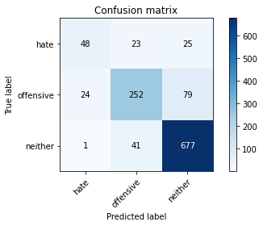

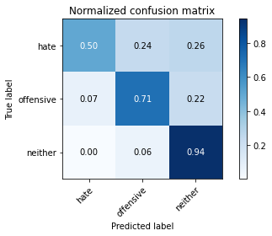

precision recall f1-score support

hate 0.66 0.50 0.57 96

offensive 0.80 0.71 0.75 355

neither 0.87 0.94 0.90 719

accuracy 0.84 1170

macro avg 0.77 0.72 0.74 1170

weighted avg 0.83 0.84 0.83 1170

average eval_loss: 0.7192828170165925, accuracy: 0.8350427350427351

training 6 epoch...

68.77270722389221 seconds used......

6 training finished! average train loss: 0.10862783549062939

total clf loss: 10.729550646618009 total adv loss: 7.344681420858251

evaluating...

Confusion matrix, without normalization

[[ 43 38 15]

[ 17 294 44]

[ 19 106 594]]

Normalized confusion matrix

[[0.44791667 0.39583333 0.15625 ]

[0.04788732 0.82816901 0.12394366]

[0.02642559 0.14742698 0.82614743]]

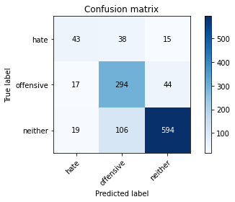

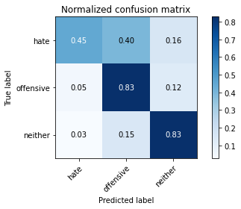

precision recall f1-score support

hate 0.54 0.45 0.49 96

offensive 0.67 0.83 0.74 355

neither 0.91 0.83 0.87 719

accuracy 0.80 1170

macro avg 0.71 0.70 0.70 1170

weighted avg 0.81 0.80 0.80 1170

average eval_loss: 0.8430004657198817, accuracy: 0.7957264957264957

training 7 epoch...

68.97074913978577 seconds used......

7 training finished! average train loss: 0.10257378426523736

total clf loss: 9.071954305691179 total adv loss: 7.465155579320708

evaluating...

Confusion matrix, without normalization

[[ 39 44 13]

[ 12 296 47]

[ 18 104 597]]

Normalized confusion matrix

[[0.40625 0.45833333 0.13541667]

[0.03380282 0.83380282 0.13239437]

[0.02503477 0.14464534 0.83031989]]

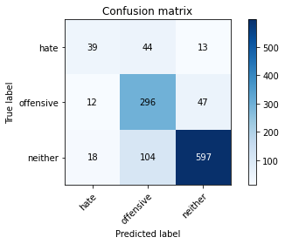

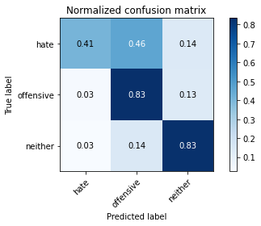

precision recall f1-score support

hate 0.57 0.41 0.47 96

offensive 0.67 0.83 0.74 355

neither 0.91 0.83 0.87 719

accuracy 0.80 1170

macro avg 0.71 0.69 0.69 1170

weighted avg 0.81 0.80 0.80 1170

average eval_loss: 0.8846738635230873, accuracy: 0.7965811965811965

training 8 epoch...

68.64805698394775 seconds used......

8 training finished! average train loss: 0.066909612788775

total clf loss: 6.174774440180045 total adv loss: 4.741037510260867

evaluating...

Confusion matrix, without normalization

[[ 49 29 18]

[ 18 278 59]

[ 12 72 635]]

Normalized confusion matrix

[[0.51041667 0.30208333 0.1875 ]

[0.05070423 0.78309859 0.16619718]

[0.01668985 0.10013908 0.88317107]]

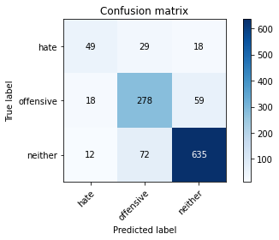

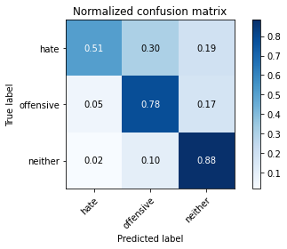

precision recall f1-score support

hate 0.62 0.51 0.56 96

offensive 0.73 0.78 0.76 355

neither 0.89 0.88 0.89 719

accuracy 0.82 1170

macro avg 0.75 0.73 0.73 1170

weighted avg 0.82 0.82 0.82 1170

average eval_loss: 0.7345285058037331, accuracy: 0.8222222222222222

training 9 epoch...

68.82460355758667 seconds used......

9 training finished! average train loss: 0.03559281848123273

total clf loss: 3.3542620690714102 total adv loss: 2.487228751362636

evaluating...

Confusion matrix, without normalization

[[ 54 27 15]

[ 22 293 40]

[ 25 104 590]]

Normalized confusion matrix

[[0.5625 0.28125 0.15625 ]

[0.06197183 0.82535211 0.11267606]

[0.03477051 0.14464534 0.82058414]]

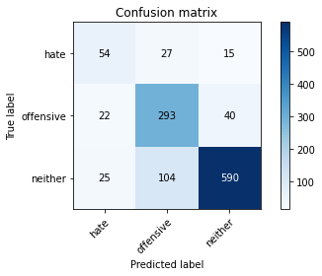

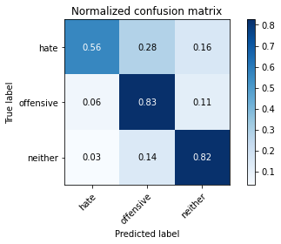

precision recall f1-score support

hate 0.53 0.56 0.55 96

offensive 0.69 0.83 0.75 355

neither 0.91 0.82 0.87 719

accuracy 0.80 1170

macro avg 0.71 0.74 0.72 1170

weighted avg 0.82 0.80 0.80 1170

average eval_loss: 0.9206113200319015, accuracy: 0.8008547008547009

training 10 epoch...

68.96479940414429 seconds used......

10 training finished! average train loss: 0.06707655242233812

total clf loss: 5.76300260797143 total adv loss: 4.96645534516756

evaluating...

Confusion matrix, without normalization

[[ 53 34 9]

[ 22 298 35]

[ 16 112 591]]

Normalized confusion matrix

[[0.55208333 0.35416667 0.09375 ]

[0.06197183 0.83943662 0.09859155]

[0.02225313 0.15577191 0.82197497]]

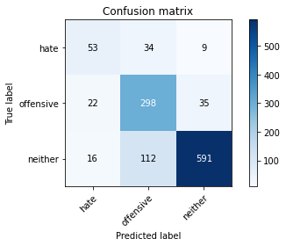

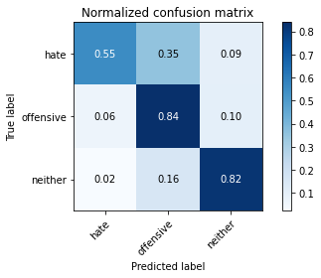

precision recall f1-score support

hate 0.58 0.55 0.57 96

offensive 0.67 0.84 0.75 355

neither 0.93 0.82 0.87 719

accuracy 0.81 1170

macro avg 0.73 0.74 0.73 1170

weighted avg 0.82 0.81 0.81 1170

average eval_loss: 0.9418648736456693, accuracy: 0.8051282051282052

3 run......

training 1 epoch...

68.93104195594788 seconds used......

1 training finished! average train loss: 1.4880394953438358

total clf loss: 142.40217505395412 total adv loss: 102.8995335996151

evaluating...

Confusion matrix, without normalization

[[ 18 55 23]

[ 4 263 88]

[ 1 50 668]]

Normalized confusion matrix

[[0.1875 0.57291667 0.23958333]

[0.01126761 0.74084507 0.24788732]

[0.00139082 0.06954103 0.92906815]]

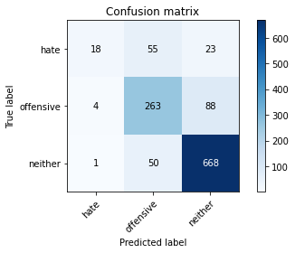

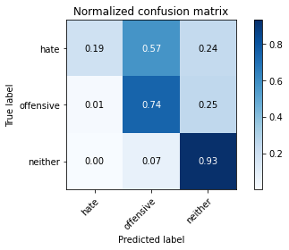

precision recall f1-score support

hate 0.78 0.19 0.30 96

offensive 0.71 0.74 0.73 355

neither 0.86 0.93 0.89 719

accuracy 0.81 1170

macro avg 0.78 0.62 0.64 1170

weighted avg 0.81 0.81 0.79 1170

average eval_loss: 0.47231608212499293, accuracy: 0.8111111111111111

training 2 epoch...

68.81358289718628 seconds used......

2 training finished! average train loss: 0.8860827310599833

total clf loss: 84.34480815380812 total adv loss: 61.49927530810237

evaluating...

Confusion matrix, without normalization

[[ 45 31 20]

[ 14 263 78]

[ 2 58 659]]

Normalized confusion matrix

[[0.46875 0.32291667 0.20833333]

[0.03943662 0.74084507 0.21971831]

[0.00278164 0.08066759 0.91655076]]

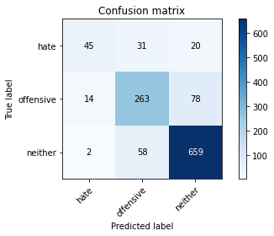

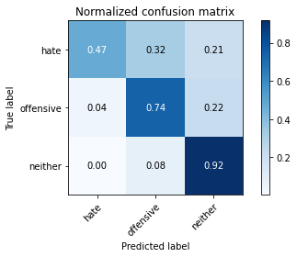

precision recall f1-score support

hate 0.74 0.47 0.57 96

offensive 0.75 0.74 0.74 355

neither 0.87 0.92 0.89 719

accuracy 0.83 1170

macro avg 0.79 0.71 0.74 1170

weighted avg 0.82 0.83 0.82 1170

average eval_loss: 0.46017080974780905, accuracy: 0.8264957264957264

training 3 epoch...

68.82606649398804 seconds used......

3 training finished! average train loss: 0.5028021295164895

total clf loss: 48.23203795403242 total adv loss: 34.71183017664589

evaluating...

Confusion matrix, without normalization

[[ 43 41 12]

[ 10 289 56]

[ 17 67 635]]

Normalized confusion matrix

[[0.44791667 0.42708333 0.125 ]

[0.02816901 0.81408451 0.15774648]

[0.02364395 0.09318498 0.88317107]]

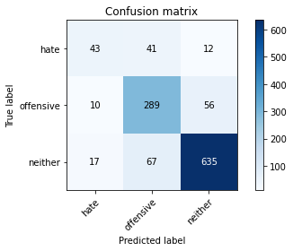

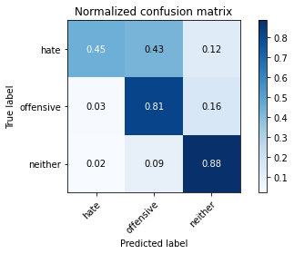

precision recall f1-score support

hate 0.61 0.45 0.52 96

offensive 0.73 0.81 0.77 355

neither 0.90 0.88 0.89 719

accuracy 0.83 1170

macro avg 0.75 0.72 0.73 1170

weighted avg 0.83 0.83 0.82 1170

average eval_loss: 0.5032950160488233, accuracy: 0.8264957264957264

training 4 epoch...

68.92155861854553 seconds used......

4 training finished! average train loss: 0.2685399038207709

total clf loss: 28.109805052401498 total adv loss: 17.36426627880428

evaluating...

Confusion matrix, without normalization

[[ 52 21 23]

[ 20 242 93]

[ 10 41 668]]

Normalized confusion matrix

[[0.54166667 0.21875 0.23958333]

[0.05633803 0.68169014 0.26197183]

[0.01390821 0.05702364 0.92906815]]

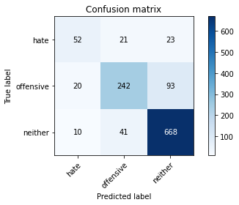

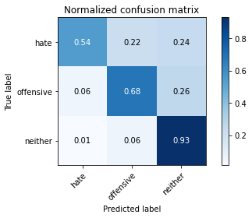

precision recall f1-score support

hate 0.63 0.54 0.58 96

offensive 0.80 0.68 0.73 355

neither 0.85 0.93 0.89 719

accuracy 0.82 1170

macro avg 0.76 0.72 0.74 1170

weighted avg 0.82 0.82 0.82 1170

average eval_loss: 0.5880892280236645, accuracy: 0.8222222222222222

training 5 epoch...

68.78718900680542 seconds used......

5 training finished! average train loss: 0.1825362749150994

total clf loss: 18.977321568410844 total adv loss: 11.868083307897905

evaluating...

Confusion matrix, without normalization

[[ 59 18 19]

[ 30 239 86]

[ 12 39 668]]

Normalized confusion matrix

[[0.61458333 0.1875 0.19791667]

[0.08450704 0.67323944 0.24225352]

[0.01668985 0.054242 0.92906815]]

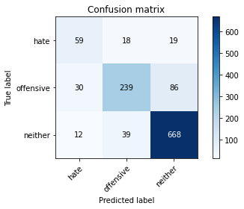

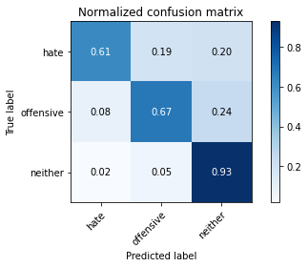

precision recall f1-score support

hate 0.58 0.61 0.60 96

offensive 0.81 0.67 0.73 355

neither 0.86 0.93 0.90 719

accuracy 0.83 1170

macro avg 0.75 0.74 0.74 1170

weighted avg 0.82 0.83 0.82 1170

average eval_loss: 0.6580162173831614, accuracy: 0.8256410256410256

training 6 epoch...

68.89817476272583 seconds used......

6 training finished! average train loss: 0.1307505374101715

total clf loss: 13.348337099188939 total adv loss: 8.623644359846367

evaluating...

Confusion matrix, without normalization

[[ 57 25 14]

[ 29 277 49]

[ 26 72 621]]

Normalized confusion matrix

[[0.59375 0.26041667 0.14583333]

[0.08169014 0.78028169 0.13802817]

[0.03616134 0.10013908 0.86369958]]

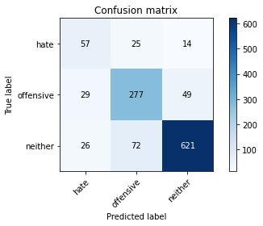

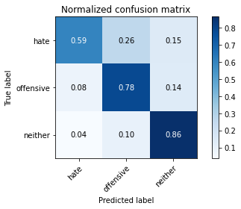

precision recall f1-score support

hate 0.51 0.59 0.55 96

offensive 0.74 0.78 0.76 355

neither 0.91 0.86 0.89 719

accuracy 0.82 1170

macro avg 0.72 0.75 0.73 1170

weighted avg 0.82 0.82 0.82 1170

average eval_loss: 0.6997130205065517, accuracy: 0.8162393162393162

training 7 epoch...

69.31199288368225 seconds used......

7 training finished! average train loss: 0.10907084321201198

total clf loss: 10.651130211655982 total adv loss: 7.435723547154339

evaluating...

Confusion matrix, without normalization

[[ 66 18 12]

[ 44 248 63]

[ 26 49 644]]

Normalized confusion matrix

[[0.6875 0.1875 0.125 ]

[0.12394366 0.69859155 0.17746479]

[0.03616134 0.06815021 0.89568846]]

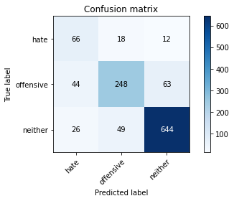

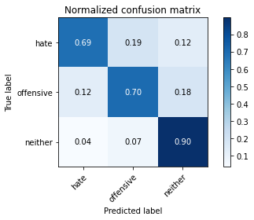

precision recall f1-score support

hate 0.49 0.69 0.57 96

offensive 0.79 0.70 0.74 355

neither 0.90 0.90 0.90 719

accuracy 0.82 1170

macro avg 0.72 0.76 0.73 1170

weighted avg 0.83 0.82 0.82 1170

average eval_loss: 0.7136061176089412, accuracy: 0.8188034188034188

training 8 epoch...

68.8003602027893 seconds used......

8 training finished! average train loss: 0.05645010521626458

total clf loss: 5.397428933240008 total adv loss: 3.9059478278104507

evaluating...

Confusion matrix, without normalization

[[ 53 28 15]

[ 25 273 57]

[ 19 64 636]]

Normalized confusion matrix

[[0.55208333 0.29166667 0.15625 ]

[0.07042254 0.76901408 0.16056338]

[0.02642559 0.08901252 0.88456189]]

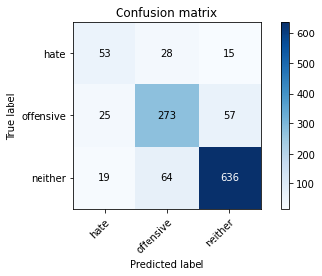

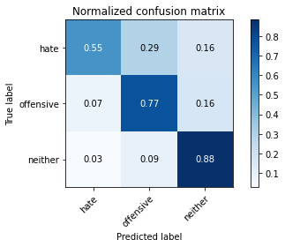

precision recall f1-score support

hate 0.55 0.55 0.55 96

offensive 0.75 0.77 0.76 355

neither 0.90 0.88 0.89 719

accuracy 0.82 1170

macro avg 0.73 0.74 0.73 1170

weighted avg 0.82 0.82 0.82 1170

average eval_loss: 0.7454055424353455, accuracy: 0.8222222222222222

training 9 epoch...

69.15937995910645 seconds used......

9 training finished! average train loss: 0.06657722030998144

total clf loss: 5.723962620802922 total adv loss: 4.927553426393388

evaluating...

Confusion matrix, without normalization

[[ 58 29 9]

[ 25 280 50]

[ 35 62 622]]

Normalized confusion matrix

[[0.60416667 0.30208333 0.09375 ]

[0.07042254 0.78873239 0.14084507]

[0.04867872 0.08623088 0.8650904 ]]

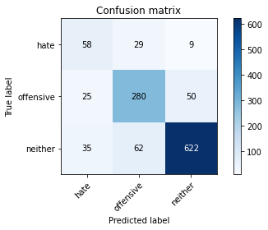

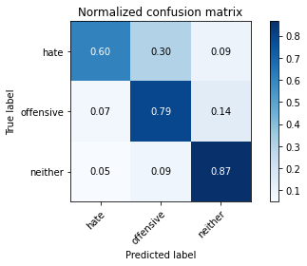

precision recall f1-score support

hate 0.49 0.60 0.54 96

offensive 0.75 0.79 0.77 355

neither 0.91 0.87 0.89 719

accuracy 0.82 1170

macro avg 0.72 0.75 0.73 1170

weighted avg 0.83 0.82 0.82 1170

average eval_loss: 0.8024514087049638, accuracy: 0.8205128205128205

training 10 epoch...

69.15240621566772 seconds used......

10 training finished! average train loss: 0.0830507449092817

total clf loss: 7.522938595458982 total adv loss: 5.955467867584957

evaluating...

Confusion matrix, without normalization

[[ 49 33 14]

[ 20 286 49]

[ 16 79 624]]

Normalized confusion matrix

[[0.51041667 0.34375 0.14583333]

[0.05633803 0.8056338 0.13802817]

[0.02225313 0.10987483 0.86787204]]

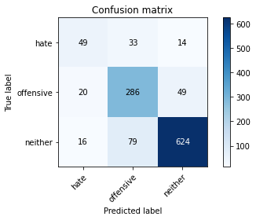

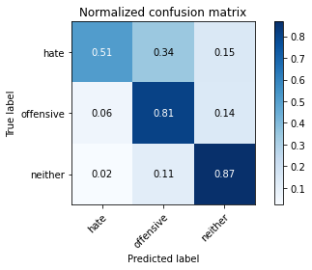

precision recall f1-score support

hate 0.58 0.51 0.54 96

offensive 0.72 0.81 0.76 355

neither 0.91 0.87 0.89 719

accuracy 0.82 1170

macro avg 0.73 0.73 0.73 1170

weighted avg 0.82 0.82 0.82 1170

average eval_loss: 0.7829542181975508, accuracy: 0.8196581196581196

4 run......

training 1 epoch...

69.06295204162598 seconds used......

1 training finished! average train loss: 1.5380251748949034

total clf loss: 147.32595537602901 total adv loss: 106.28596794605255

evaluating...

Confusion matrix, without normalization

[[ 22 48 26]

[ 1 259 95]

[ 2 57 660]]

Normalized confusion matrix

[[0.22916667 0.5 0.27083333]

[0.0028169 0.72957746 0.26760563]

[0.00278164 0.07927677 0.91794159]]

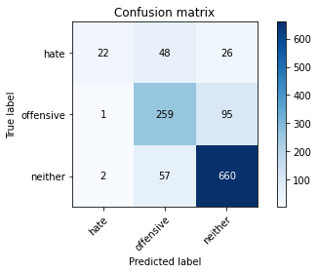

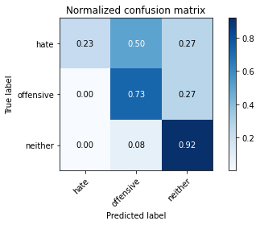

precision recall f1-score support

hate 0.88 0.23 0.36 96

offensive 0.71 0.73 0.72 355

neither 0.85 0.92 0.88 719

accuracy 0.80 1170

macro avg 0.81 0.63 0.65 1170

weighted avg 0.81 0.80 0.79 1170

average eval_loss: 0.4986818066592944, accuracy: 0.8042735042735043

training 2 epoch...

69.12256026268005 seconds used......

2 training finished! average train loss: 0.9796133925899481

total clf loss: 94.15564484894276 total adv loss: 67.5369442999363

evaluating...

Confusion matrix, without normalization

[[ 35 42 19]

[ 6 285 64]

[ 9 73 637]]

Normalized confusion matrix

[[0.36458333 0.4375 0.19791667]

[0.01690141 0.8028169 0.18028169]

[0.01251739 0.1015299 0.88595271]]

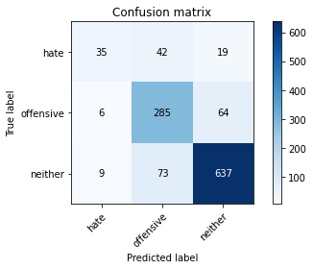

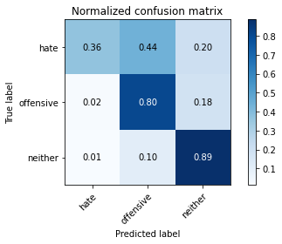

precision recall f1-score support

hate 0.70 0.36 0.48 96

offensive 0.71 0.80 0.75 355

neither 0.88 0.89 0.89 719

accuracy 0.82 1170

macro avg 0.77 0.68 0.71 1170

weighted avg 0.82 0.82 0.81 1170

average eval_loss: 0.452677654639139, accuracy: 0.8179487179487179

training 3 epoch...

69.430997133255 seconds used......

3 training finished! average train loss: 0.5294086339955146

total clf loss: 52.55934962257743 total adv loss: 35.661135324276984

evaluating...

Confusion matrix, without normalization

[[ 37 41 18]

[ 10 286 59]

[ 10 68 641]]

Normalized confusion matrix

[[0.38541667 0.42708333 0.1875 ]

[0.02816901 0.8056338 0.16619718]

[0.01390821 0.0945758 0.89151599]]

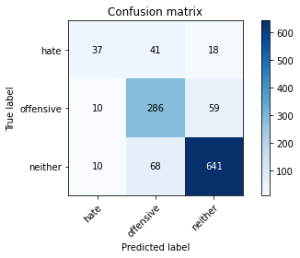

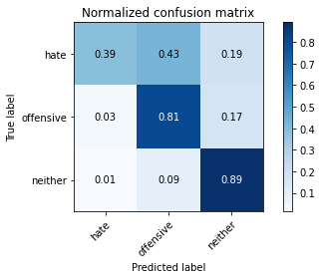

precision recall f1-score support

hate 0.65 0.39 0.48 96

offensive 0.72 0.81 0.76 355

neither 0.89 0.89 0.89 719

accuracy 0.82 1170

macro avg 0.76 0.69 0.71 1170

weighted avg 0.82 0.82 0.82 1170

average eval_loss: 0.5127573140849502, accuracy: 0.8239316239316239

training 4 epoch...

69.2494204044342 seconds used......

4 training finished! average train loss: 0.2792789599277143

total clf loss: 29.744616112671793 total adv loss: 17.803330366616137

evaluating...

Confusion matrix, without normalization

[[ 47 28 21]

[ 30 252 73]

[ 18 48 653]]

Normalized confusion matrix

[[0.48958333 0.29166667 0.21875 ]

[0.08450704 0.70985915 0.2056338 ]

[0.02503477 0.06675939 0.90820584]]

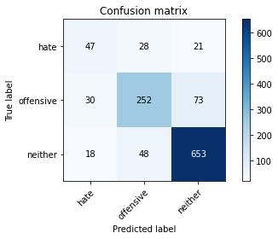

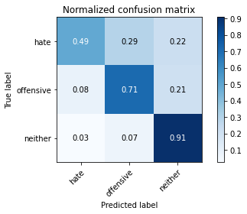

precision recall f1-score support

hate 0.49 0.49 0.49 96

offensive 0.77 0.71 0.74 355

neither 0.87 0.91 0.89 719

accuracy 0.81 1170

macro avg 0.71 0.70 0.71 1170

weighted avg 0.81 0.81 0.81 1170

average eval_loss: 0.6394354060797368, accuracy: 0.8136752136752137

training 5 epoch...

69.38671231269836 seconds used......

5 training finished! average train loss: 0.18029221078643623

total clf loss: 19.565864139935 total adv loss: 11.311256584667717

evaluating...

Confusion matrix, without normalization

[[ 56 21 19]

[ 31 254 70]

[ 15 46 658]]

Normalized confusion matrix

[[0.58333333 0.21875 0.19791667]

[0.08732394 0.71549296 0.1971831 ]

[0.02086231 0.06397775 0.91515994]]

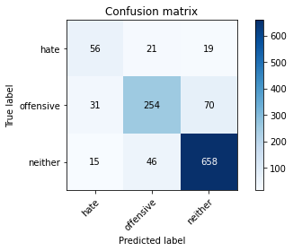

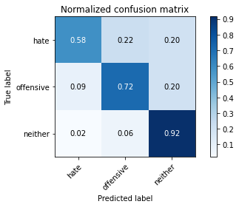

precision recall f1-score support

hate 0.55 0.58 0.57 96

offensive 0.79 0.72 0.75 355

neither 0.88 0.92 0.90 719

accuracy 0.83 1170

macro avg 0.74 0.74 0.74 1170

weighted avg 0.83 0.83 0.83 1170

average eval_loss: 0.6351848823586637, accuracy: 0.8273504273504273

training 6 epoch...

69.11362218856812 seconds used......

6 training finished! average train loss: 0.13589063566775086

total clf loss: 14.821270743734203 total adv loss: 8.488569051027298

evaluating...

Confusion matrix, without normalization

[[ 49 26 21]

[ 22 262 71]

[ 13 56 650]]

Normalized confusion matrix

[[0.51041667 0.27083333 0.21875 ]

[0.06197183 0.73802817 0.2 ]

[0.01808067 0.07788595 0.90403338]]

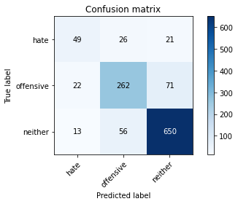

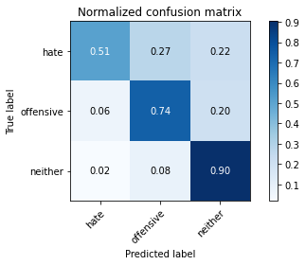

precision recall f1-score support

hate 0.58 0.51 0.54 96

offensive 0.76 0.74 0.75 355

neither 0.88 0.90 0.89 719

accuracy 0.82 1170

macro avg 0.74 0.72 0.73 1170

weighted avg 0.82 0.82 0.82 1170

average eval_loss: 0.6989398312013028, accuracy: 0.8213675213675213

training 7 epoch...

69.0711715221405 seconds used......

7 training finished! average train loss: 0.1076378119814918

total clf loss: 10.298480973346159 total adv loss: 7.444383526024467

evaluating...

Confusion matrix, without normalization

[[ 64 13 19]

[ 38 243 74]

[ 20 36 663]]

Normalized confusion matrix

[[0.66666667 0.13541667 0.19791667]

[0.10704225 0.68450704 0.2084507 ]

[0.02781641 0.05006954 0.92211405]]

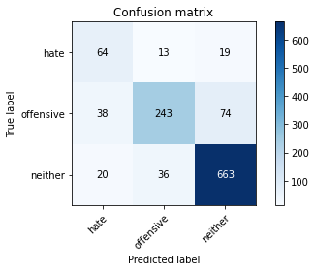

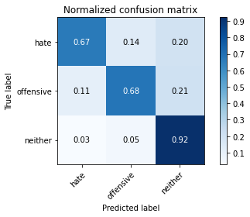

precision recall f1-score support

hate 0.52 0.67 0.59 96

offensive 0.83 0.68 0.75 355

neither 0.88 0.92 0.90 719

accuracy 0.83 1170

macro avg 0.74 0.76 0.75 1170

weighted avg 0.83 0.83 0.83 1170

average eval_loss: 0.787333440264466, accuracy: 0.8290598290598291

training 8 epoch...

69.2844386100769 seconds used......

8 training finished! average train loss: 0.07707637534417117

total clf loss: 8.174822139320895 total adv loss: 4.930524827697809

evaluating...

Confusion matrix, without normalization

[[ 62 20 14]

[ 32 266 57]

[ 30 55 634]]

Normalized confusion matrix

[[0.64583333 0.20833333 0.14583333]

[0.09014085 0.74929577 0.16056338]

[0.04172462 0.07649513 0.88178025]]

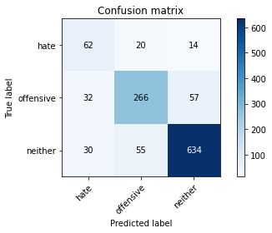

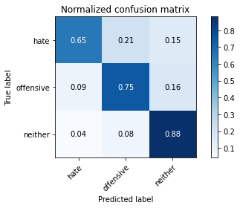

precision recall f1-score support

hate 0.50 0.65 0.56 96

offensive 0.78 0.75 0.76 355

neither 0.90 0.88 0.89 719

accuracy 0.82 1170

macro avg 0.73 0.76 0.74 1170

weighted avg 0.83 0.82 0.83 1170

average eval_loss: 0.7923410146228843, accuracy: 0.8222222222222222

training 9 epoch...

69.08068323135376 seconds used......

9 training finished! average train loss: 0.07806658409993586

total clf loss: 7.183085957949515 total adv loss: 5.542247318619047

evaluating...

Confusion matrix, without normalization

[[ 70 18 8]

[ 45 255 55]

[ 22 64 633]]

Normalized confusion matrix

[[0.72916667 0.1875 0.08333333]

[0.12676056 0.71830986 0.15492958]

[0.03059805 0.08901252 0.88038943]]

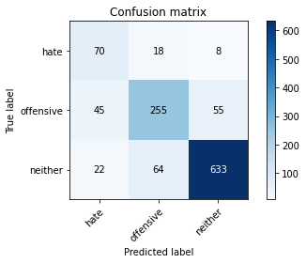

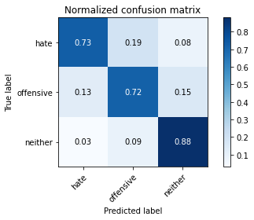

precision recall f1-score support

hate 0.51 0.73 0.60 96

offensive 0.76 0.72 0.74 355

neither 0.91 0.88 0.89 719

accuracy 0.82 1170

macro avg 0.73 0.78 0.74 1170

weighted avg 0.83 0.82 0.82 1170

average eval_loss: 0.845460469408308, accuracy: 0.8188034188034188

training 10 epoch...

69.03678321838379 seconds used......

10 training finished! average train loss: 0.07370331838729982

total clf loss: 6.613383733667433 total adv loss: 5.316596414657397

evaluating...

Confusion matrix, without normalization

[[ 49 34 13]

[ 19 288 48]

[ 18 87 614]]

Normalized confusion matrix

[[0.51041667 0.35416667 0.13541667]

[0.05352113 0.81126761 0.13521127]

[0.02503477 0.12100139 0.85396384]]

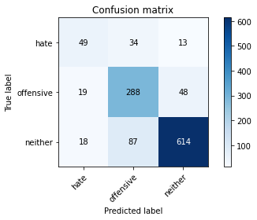

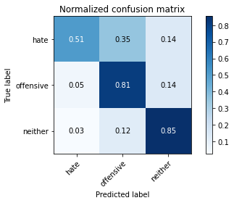

precision recall f1-score support

hate 0.57 0.51 0.54 96

offensive 0.70 0.81 0.75 355

neither 0.91 0.85 0.88 719

accuracy 0.81 1170

macro avg 0.73 0.73 0.72 1170

weighted avg 0.82 0.81 0.81 1170

average eval_loss: 0.8529545361239274, accuracy: 0.8128205128205128

5 run......

training 1 epoch...

69.24594163894653 seconds used......

1 training finished! average train loss: 1.5163794339467318

total clf loss: 145.19119969010353 total adv loss: 104.82079391181469

evaluating...

Confusion matrix, without normalization

[[ 5 52 39]

[ 0 234 121]

[ 0 31 688]]

Normalized confusion matrix

[[0.05208333 0.54166667 0.40625 ]

[0. 0.65915493 0.34084507]

[0. 0.04311544 0.95688456]]

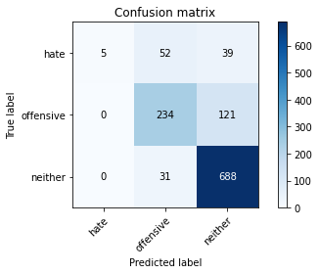

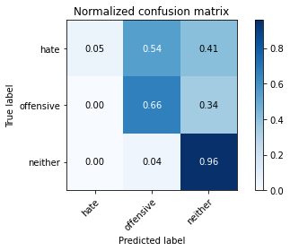

precision recall f1-score support

hate 1.00 0.05 0.10 96

offensive 0.74 0.66 0.70 355

neither 0.81 0.96 0.88 719

accuracy 0.79 1170

macro avg 0.85 0.56 0.56 1170

weighted avg 0.80 0.79 0.76 1170

average eval_loss: 0.5024686165280261, accuracy: 0.7923076923076923

training 2 epoch...

69.29835796356201 seconds used......

2 training finished! average train loss: 0.9782958911397518

total clf loss: 92.83879625052214 total adv loss: 68.04122088849545

evaluating...

Confusion matrix, without normalization

[[ 16 45 35]

[ 2 246 107]

[ 2 30 687]]

Normalized confusion matrix

[[0.16666667 0.46875 0.36458333]

[0.0056338 0.69295775 0.30140845]

[0.00278164 0.04172462 0.95549374]]

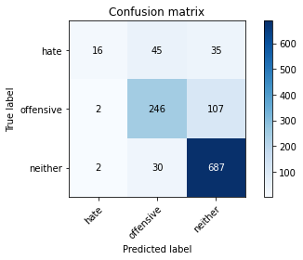

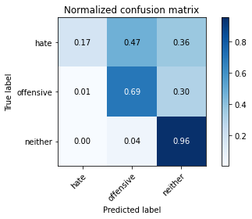

precision recall f1-score support

hate 0.80 0.17 0.28 96

offensive 0.77 0.69 0.73 355

neither 0.83 0.96 0.89 719

accuracy 0.81 1170

macro avg 0.80 0.61 0.63 1170

weighted avg 0.81 0.81 0.79 1170

average eval_loss: 0.48422956605583933, accuracy: 0.8111111111111111

training 3 epoch...

69.23552060127258 seconds used......

3 training finished! average train loss: 0.5573728241217442

total clf loss: 54.330097861588 total adv loss: 38.04757132101804

evaluating...

Confusion matrix, without normalization

[[ 52 29 15]

[ 13 288 54]

[ 20 68 631]]

Normalized confusion matrix

[[0.54166667 0.30208333 0.15625 ]

[0.03661972 0.81126761 0.15211268]

[0.02781641 0.0945758 0.87760779]]

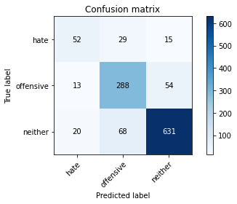

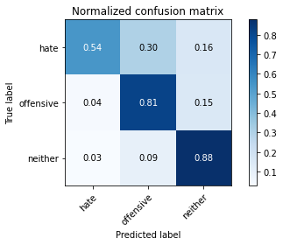

precision recall f1-score support

hate 0.61 0.54 0.57 96

offensive 0.75 0.81 0.78 355

neither 0.90 0.88 0.89 719

accuracy 0.83 1170

macro avg 0.75 0.74 0.75 1170

weighted avg 0.83 0.83 0.83 1170

average eval_loss: 0.5166783553185099, accuracy: 0.82991452991453

training 4 epoch...

69.11803078651428 seconds used......

4 training finished! average train loss: 0.3002573759812448

total clf loss: 31.204655890353024 total adv loss: 19.527785011043306

evaluating...

Confusion matrix, without normalization

[[ 36 42 18]

[ 20 268 67]

[ 17 62 640]]

Normalized confusion matrix

[[0.375 0.4375 0.1875 ]

[0.05633803 0.75492958 0.18873239]

[0.02364395 0.08623088 0.89012517]]

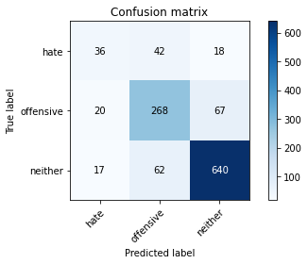

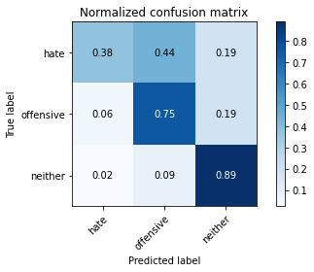

precision recall f1-score support

hate 0.49 0.38 0.43 96

offensive 0.72 0.75 0.74 355

neither 0.88 0.89 0.89 719

accuracy 0.81 1170

macro avg 0.70 0.67 0.68 1170

weighted avg 0.80 0.81 0.80 1170

average eval_loss: 0.629359830928556, accuracy: 0.8068376068376069

training 5 epoch...

68.95058226585388 seconds used......

5 training finished! average train loss: 0.19962811544855946

total clf loss: 20.718546293210238 total adv loss: 12.997216252872022

evaluating...

Confusion matrix, without normalization

[[ 45 31 20]

[ 17 273 65]

[ 23 62 634]]

Normalized confusion matrix

[[0.46875 0.32291667 0.20833333]

[0.04788732 0.76901408 0.18309859]

[0.03198887 0.08623088 0.88178025]]

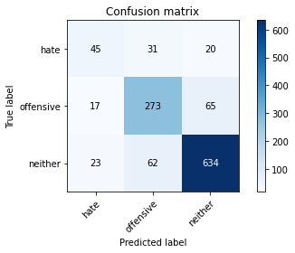

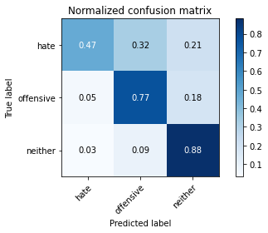

precision recall f1-score support

hate 0.53 0.47 0.50 96

offensive 0.75 0.77 0.76 355

neither 0.88 0.88 0.88 719

accuracy 0.81 1170

macro avg 0.72 0.71 0.71 1170

weighted avg 0.81 0.81 0.81 1170

average eval_loss: 0.66558386284416, accuracy: 0.8136752136752137

training 6 epoch...

69.03384327888489 seconds used......

6 training finished! average train loss: 0.15344224899557507

total clf loss: 15.106214030529372 total adv loss: 10.399635978712467

evaluating...

Confusion matrix, without normalization

[[ 58 20 18]

[ 42 252 61]

[ 34 48 637]]

Normalized confusion matrix

[[0.60416667 0.20833333 0.1875 ]

[0.11830986 0.70985915 0.17183099]

[0.0472879 0.06675939 0.88595271]]

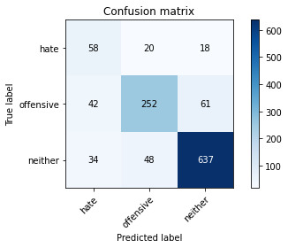

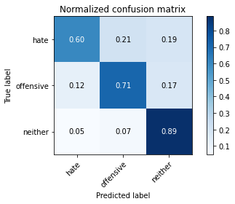

precision recall f1-score support

hate 0.43 0.60 0.50 96

offensive 0.79 0.71 0.75 355

neither 0.89 0.89 0.89 719

accuracy 0.81 1170

macro avg 0.70 0.73 0.71 1170

weighted avg 0.82 0.81 0.81 1170

average eval_loss: 0.7362064389606654, accuracy: 0.8094017094017094

training 7 epoch...

68.93147206306458 seconds used......

7 training finished! average train loss: 0.08375415350230904

total clf loss: 8.256737121730112 total adv loss: 5.670867368367908

evaluating...

Confusion matrix, without normalization

[[ 57 21 18]

[ 39 249 67]

[ 34 48 637]]

Normalized confusion matrix

[[0.59375 0.21875 0.1875 ]

[0.10985915 0.70140845 0.18873239]

[0.0472879 0.06675939 0.88595271]]

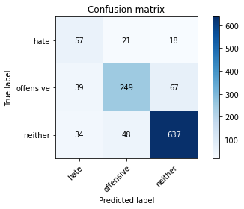

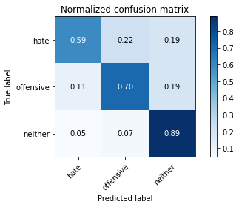

precision recall f1-score support

hate 0.44 0.59 0.50 96

offensive 0.78 0.70 0.74 355

neither 0.88 0.89 0.88 719

accuracy 0.81 1170

macro avg 0.70 0.73 0.71 1170

weighted avg 0.82 0.81 0.81 1170

average eval_loss: 0.794322799828093, accuracy: 0.805982905982906

training 8 epoch...

69.11876058578491 seconds used......

8 training finished! average train loss: 0.0788934854807981

total clf loss: 7.418145470001036 total adv loss: 5.521465108067787

evaluating...

Confusion matrix, without normalization

[[ 60 16 20]

[ 43 229 83]

[ 23 36 660]]

Normalized confusion matrix

[[0.625 0.16666667 0.20833333]

[0.12112676 0.64507042 0.23380282]

[0.03198887 0.05006954 0.91794159]]

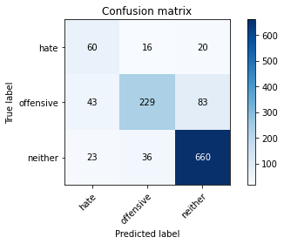

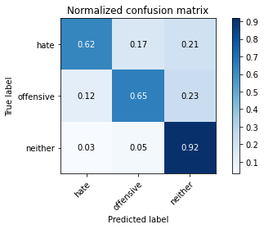

precision recall f1-score support

hate 0.48 0.62 0.54 96

offensive 0.81 0.65 0.72 355

neither 0.87 0.92 0.89 719

accuracy 0.81 1170

macro avg 0.72 0.73 0.72 1170

weighted avg 0.82 0.81 0.81 1170

average eval_loss: 0.8817919806214207, accuracy: 0.8111111111111111

training 9 epoch...

69.10561656951904 seconds used......

9 training finished! average train loss: 0.07671182065342481

total clf loss: 7.555207181489095 total adv loss: 5.197679436729231

evaluating...

Confusion matrix, without normalization

[[ 59 19 18]

[ 34 248 73]

[ 33 40 646]]

Normalized confusion matrix

[[0.61458333 0.19791667 0.1875 ]

[0.09577465 0.69859155 0.2056338 ]

[0.04589708 0.05563282 0.8984701 ]]

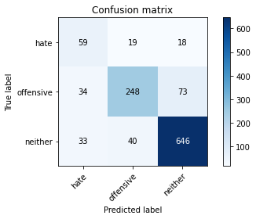

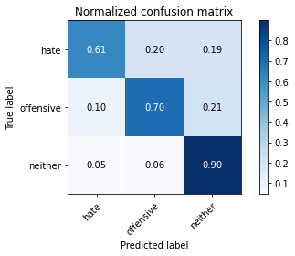

precision recall f1-score support

hate 0.47 0.61 0.53 96

offensive 0.81 0.70 0.75 355

neither 0.88 0.90 0.89 719

accuracy 0.81 1170

macro avg 0.72 0.74 0.72 1170

weighted avg 0.82 0.81 0.82 1170

average eval_loss: 0.8790953897918432, accuracy: 0.8145299145299145

training 10 epoch...

69.12523889541626 seconds used......

10 training finished! average train loss: 0.04340171788841024

total clf loss: 4.307557573803933 total adv loss: 2.924222215948248

evaluating...

Confusion matrix, without normalization

[[ 54 22 20]

[ 29 265 61]

[ 12 52 655]]

Normalized confusion matrix

[[0.5625 0.22916667 0.20833333]

[0.08169014 0.74647887 0.17183099]

[0.01668985 0.07232267 0.91098748]]

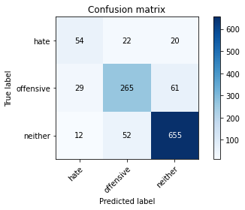

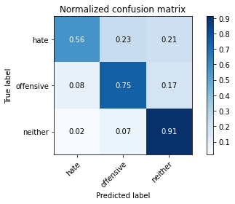

precision recall f1-score support

hate 0.57 0.56 0.57 96

offensive 0.78 0.75 0.76 355

neither 0.89 0.91 0.90 719

accuracy 0.83 1170

macro avg 0.75 0.74 0.74 1170

weighted avg 0.83 0.83 0.83 1170

average eval_loss: 0.9080287400885658, accuracy: 0.8324786324786325